**IMPORTANCE OF 5G IN INDIAN EDUCATION SYSTEM**

**Abstract**

Fifth generation wireless communications are denoted by 5G technology. 5G schemes are coming from first generation analog communication, 2G of Global System for Mobile communication (GSM), then 3G of Code Division Multiple Access (CDMA), after that fourth generation of long-term evaluation (LTE), and now fifth generation World Wide Wireless Web (WWWW). This research investigation presents issues, challenges, and the importance of 5G Wifi communication. In the 5G digital cellular network, the coverage area of the service providers is separated into small area called cells. All the audio, video, and image files are digitized and converted by an ADC (Analog to Digital Converter) and transmitted through stream of bits. 5G wireless devices are communicated using radio waves in a geographically reusable common pool of frequency band. Using wireless backhaul connection, the local antennas are connected with the internet/telephone network. Spectrum speed is substantially higher in millimeter wave. Hence, this was considered in this work

***What is 5G?***

5G technology represents the next-gen milestone for endless wireless communication, connecting devices, machines, businesses and people. What sets 5G apart in India and elsewhere is its ability to deliver several Gbps higher 5G data speeds, massive bandwidth and network capacity, ultra-low latency, better availability and greater reliability compared to any other cellular network.

This advancement in the form of 5G mobile connectivity technology is enabling a more consistent user experience and the emergence of 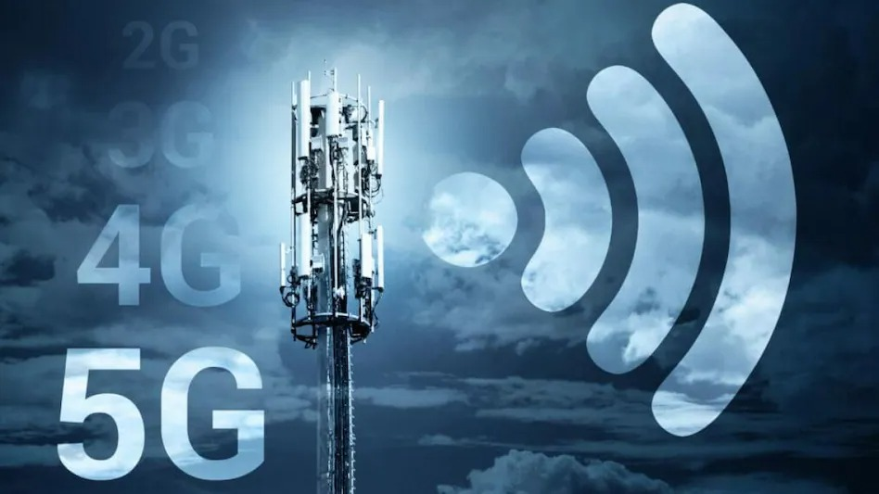new services, applications and experiences

that are connecting the world at a dizzying pace.

Why is it important to adopt a 5G network?

A fifth-generation or 5G wireless technology is the latest milestone of cellular network operations. It's an upgraded version of 4G. It facilitates organisations and people in causation and receiving fast info thanks to an especially low latency rate.

For contemporary academic establishments, it will help within the faster, reliable and power tool mode of education delivery. In less complicated words, it is easier to mention that a 5G network can help ten times over a 4G network. It's not wrong to say that prime latency with larger accessibility can support institutions with hovering economical communication over tiny or larger distances.

*Impact on Indian education system and students:*

Uplift to on-line learning and  management

Education establishments selecting technologies for automation and digital transformation will optimise the 5G network. It can create learning on the go easier, providing larger responsiveness and speed across all the devices, portals and mobile applications. It can boost online learning along side effective management of educational and body tasks if used with platforms like ERP or SIS.

*I*

*Improved interaction between school and students.*

**

within the Covid-19 pandemic, establishments should have understood the worth of on-line learning and its impact. establishments that have opted for technologies like ERP/SIS got a replacement way. However, institutions even have to grasp that they would like a high propensity network which will connect and communicate with high intensity and bandwidth.

This way, 5G can become a good answer that can improve quality and dependability around the globe. An honest speed affiliation improves video conferencing quality, speed and overall property. A 5G network conjointly permits connectivity among school and students in overall segments.

*Accelerated quality and adoption of hybrid learning*

The advanced situation of education establishments needs everything online. It desires additional tactile stimulation to accomplish teaching and learning objectives. Adopting a hybrid model of learning and exploring ideas just like the integration of square measure and VR into lecture rooms is helpful during this way.



5G will give institutions with larger network capability and seamless experience, permitting learners to explore feeling, touch, motion and interaction.

*Customised learning experiences*

The standard learning pattern in academic institutions follows the one-size-fits-all approach. Utilising 5G, institutions can realise an easier thanks to amendment that with package like ERP/SIS. it'll improve the customizations in learning patterns. The implications of the proper technology with a robust network will implement advanced learning patterns. It conjointly depicts customised learning experiences.

*Distributed cloud data*

Cloud-based storage facilitates the students and teachers in accessing the information anyplace and at any time. however generally there's a delay in accessing the data here even with a comparatively quick net connection. So, as it is cumbersome, 5G will help us. Future mobile technology will help us in accessing the data anywhere by utilising distributed cloud and mobile edge computing. there'll be immediate response and also the students will simply resume their work per their convenient time and place.

*As like we had discussed the importance of 5g technology,here are some disadvantages:*

Cybersecurity Risk: Another drawback of 5G technology is it **increases the risk of hacking thus impinging on cybersecurity**. Moreover, lack of encryption during the connection process also makes the devices using 5G technology an easier target for cyberattacks and data theft.

* Although 5G's short wavelength and range make it non-ionizing, **it is still possible to pose a risk to the environment and human health**. Most importantly, 5G will increase the amount of electromagnetic radiation in the atmosphere, leading to an increased risk for disease and a high risk of cancer.
* People also should face the problem of adapting 5g supportable phone by exchanging their existing 4g supporting mobiles which may brings financial risk to lower income group people.

***Conclusion:***

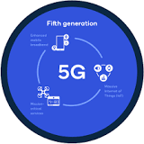

* 5G wireless technology is meant to deliver higher multi-Gbps peak data speeds, ultra low latency, more reliability, massive network capacity, increased availability, and a more uniform user experience to more users. Higher performance and improved efficiency empower new user experiences and connects new industries.

And from the above discussion we can understand that it can help education system in better manner. But still we should have an eye towards 5g as it is might be a disadvantage.